Supervisor (Lady Supervisor / ANM / SHN) – Roles and Functionalities
The Supervisor (Lady Supervisor / ANM / SHN) plays a critical role and primarily functions as the verification or checker level in most workflows of the scheme. After the Field Functionary (AWW/ASHA) enters beneficiary details or updates service delivery milestones, the Supervisor is responsible for reviewing and verifying the information before it is forwarded to the Sanctioning Officer for approval. This verification layer helps ensure the accuracy of beneficiary data, compliance with scheme guidelines, and correctness of service delivery records.
Through the Supervisor login in PMMVY application, multiple functionalities are available to support verification, data review, reporting, and tracking of beneficiaries under the scheme. These functionalities allow Supervisors to verify registrations, check childbirth and immunization details, process case closure requests, authenticate field functionaries, update residency period details, and generate important reports for monitoring scheme implementation.

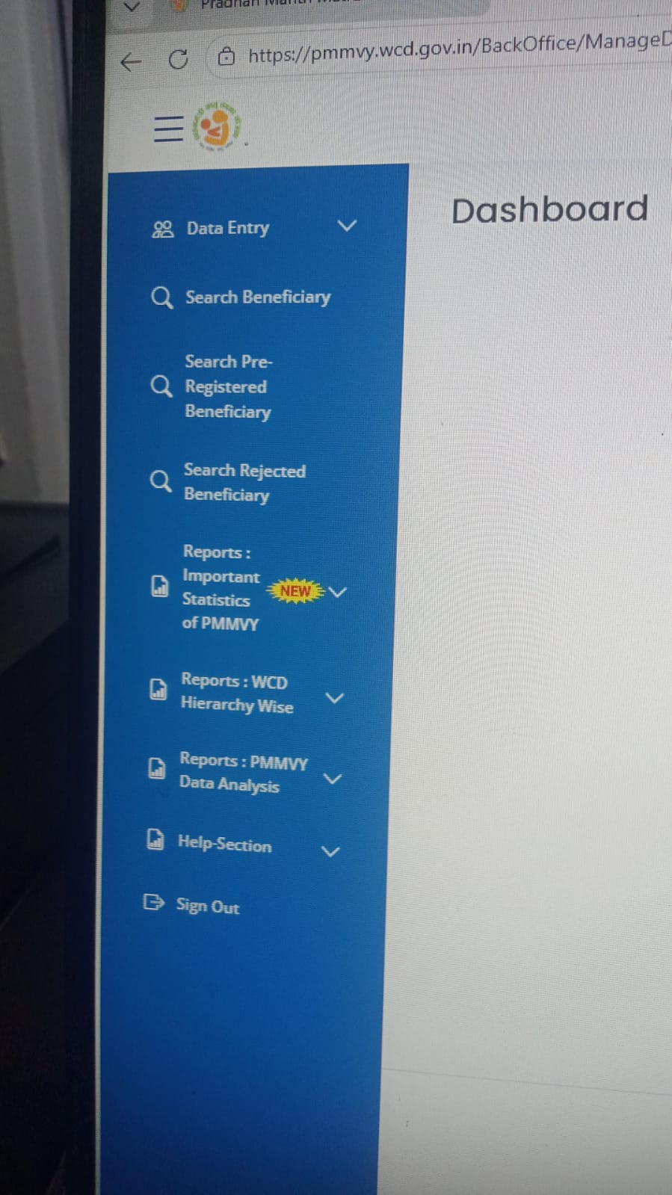

Key functionalities available in Supervisor Login
Functionalities available in the Supervisor (Lady Supervisor/ANM/SHN) Login include:
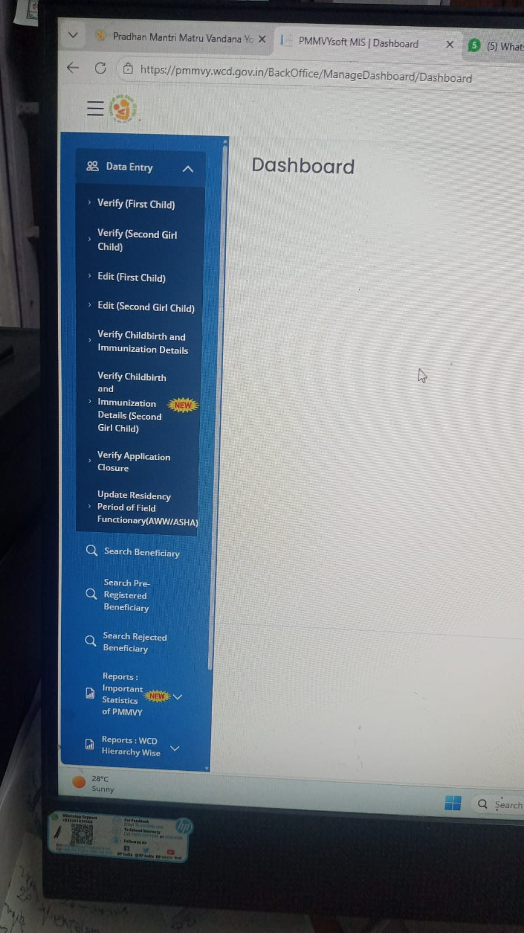
Home
- Data Entry​
  - Verify First Child​
  - Verify Second Girl Child​
  - Edit First Child​
  - Edit Second Girl Child​
  - Verify Childbirth & Immunization Details​
  - Verify Childbirth and Immunization Details(Second Girl Child)​
  - Verify Application Closure​
  - Face Authentication of FF(AWW/ASHA)
  - Update Residency Period of Field Functionary (AWW/ASHA) ​

- Search Beneficiary ​
  - Search Pre-registered Beneficiary ​
  - Search Rejected Beneficiary ​
- Reports: Important Statistics of PMMVY​
  - LGD - WCD Hierarchy Pendency Status​
  - Facial Recognition from POSHAN Tracker​
  - Due List of the Potential Beneficiaries from PTfor PMMVY​
  - List of Beneficiaries whose Aadhaar Deseeded​
  - Due-list segmented by time left for registration
  - Aadhar and face authenticated of FF
- Reports: WCD Hierarchy Wise​
  - PMMVY Implementation Status Financial year-wise​
  - Detailed Enrollment Status​
  - FF(AWW/ASHA) Aadhaar​
  - Pre-registered Beneficiaries in PMMVY​
  - Case Closure​
- Reports: PMMVY Data Analysis​
  - Child birth place
  - Analysis of eligibility criteria
  - Analysis of # ongoing beneficiaries in AWC
- Help
  - Check NPCI mapping status of NPCI mapped
  - Check NPCI mapping of AADHAR deseeded beneficiaries

CHAPTER 6: Verify Beneficiary Registration (First / Second Girl Child)
Verification of beneficiary registration is one of the key responsibilities of the Supervisor before forwarding the case for approval. The steps are as follows:
- Click on “Data Entry” tab.
- Select “Verify (First Child)” or “Verify (Second Girl Child)”.
- List of beneficiaries will be displayed.
- Click on “Verify” button.
- Beneficiary registration form will open.
- Review all details.
- Click:
  - “Verify” → Form moves to Sanctioning Officer for approval.
  - “Not Verify” → If details are incorrect.

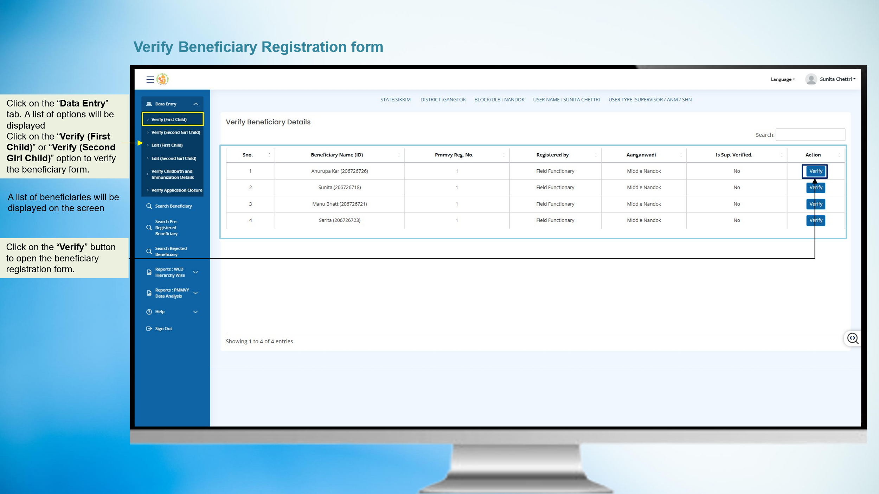



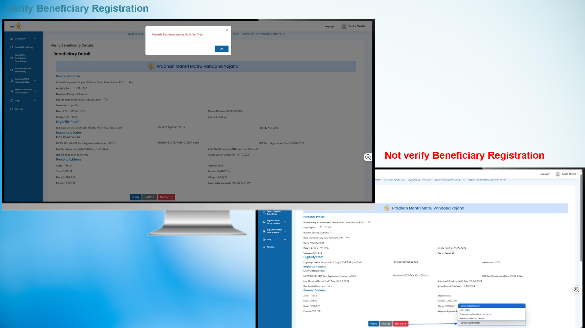

Edit Beneficiary Registration Details (First / Second Girl Child)
The Supervisor can edit certain beneficiary details after reviewing the registration information submitted by the Field Functionary. The Steps are as follows:
- Click on “Data Entry” tab.
- Select “Edit (First Child)” or “Edit (Second Girl Child)”.
- List of beneficiaries will be displayed.
- Click on “Edit” button.
- Beneficiary registration form will open.
- Edit the details which are editable.
- Click on “Submit” button.
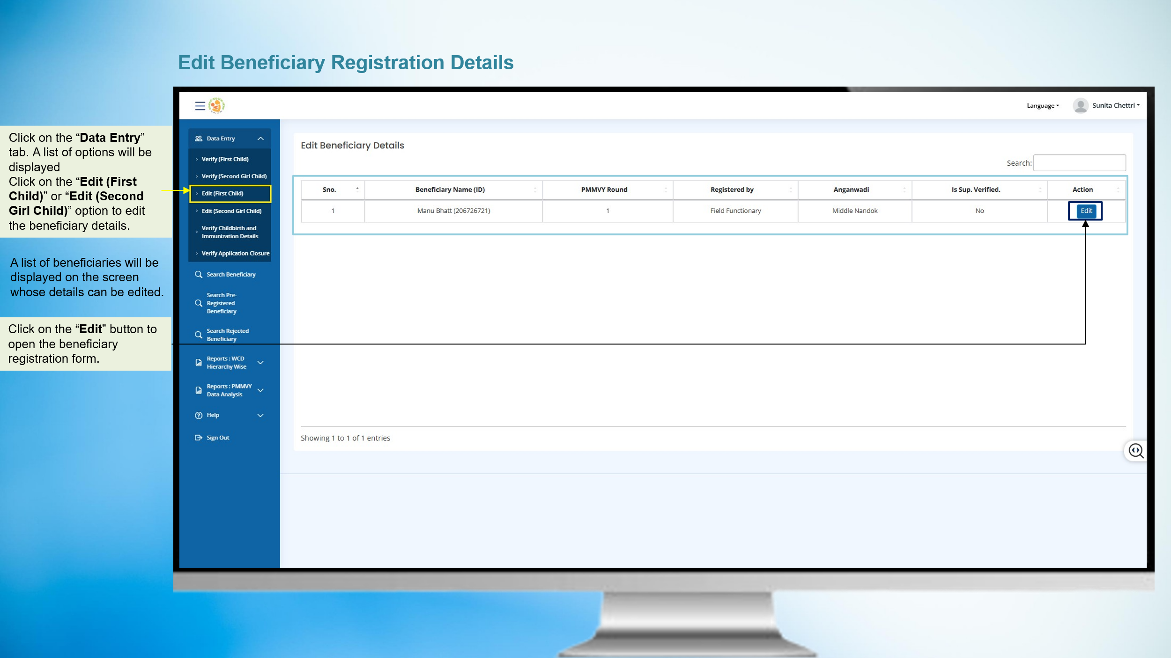

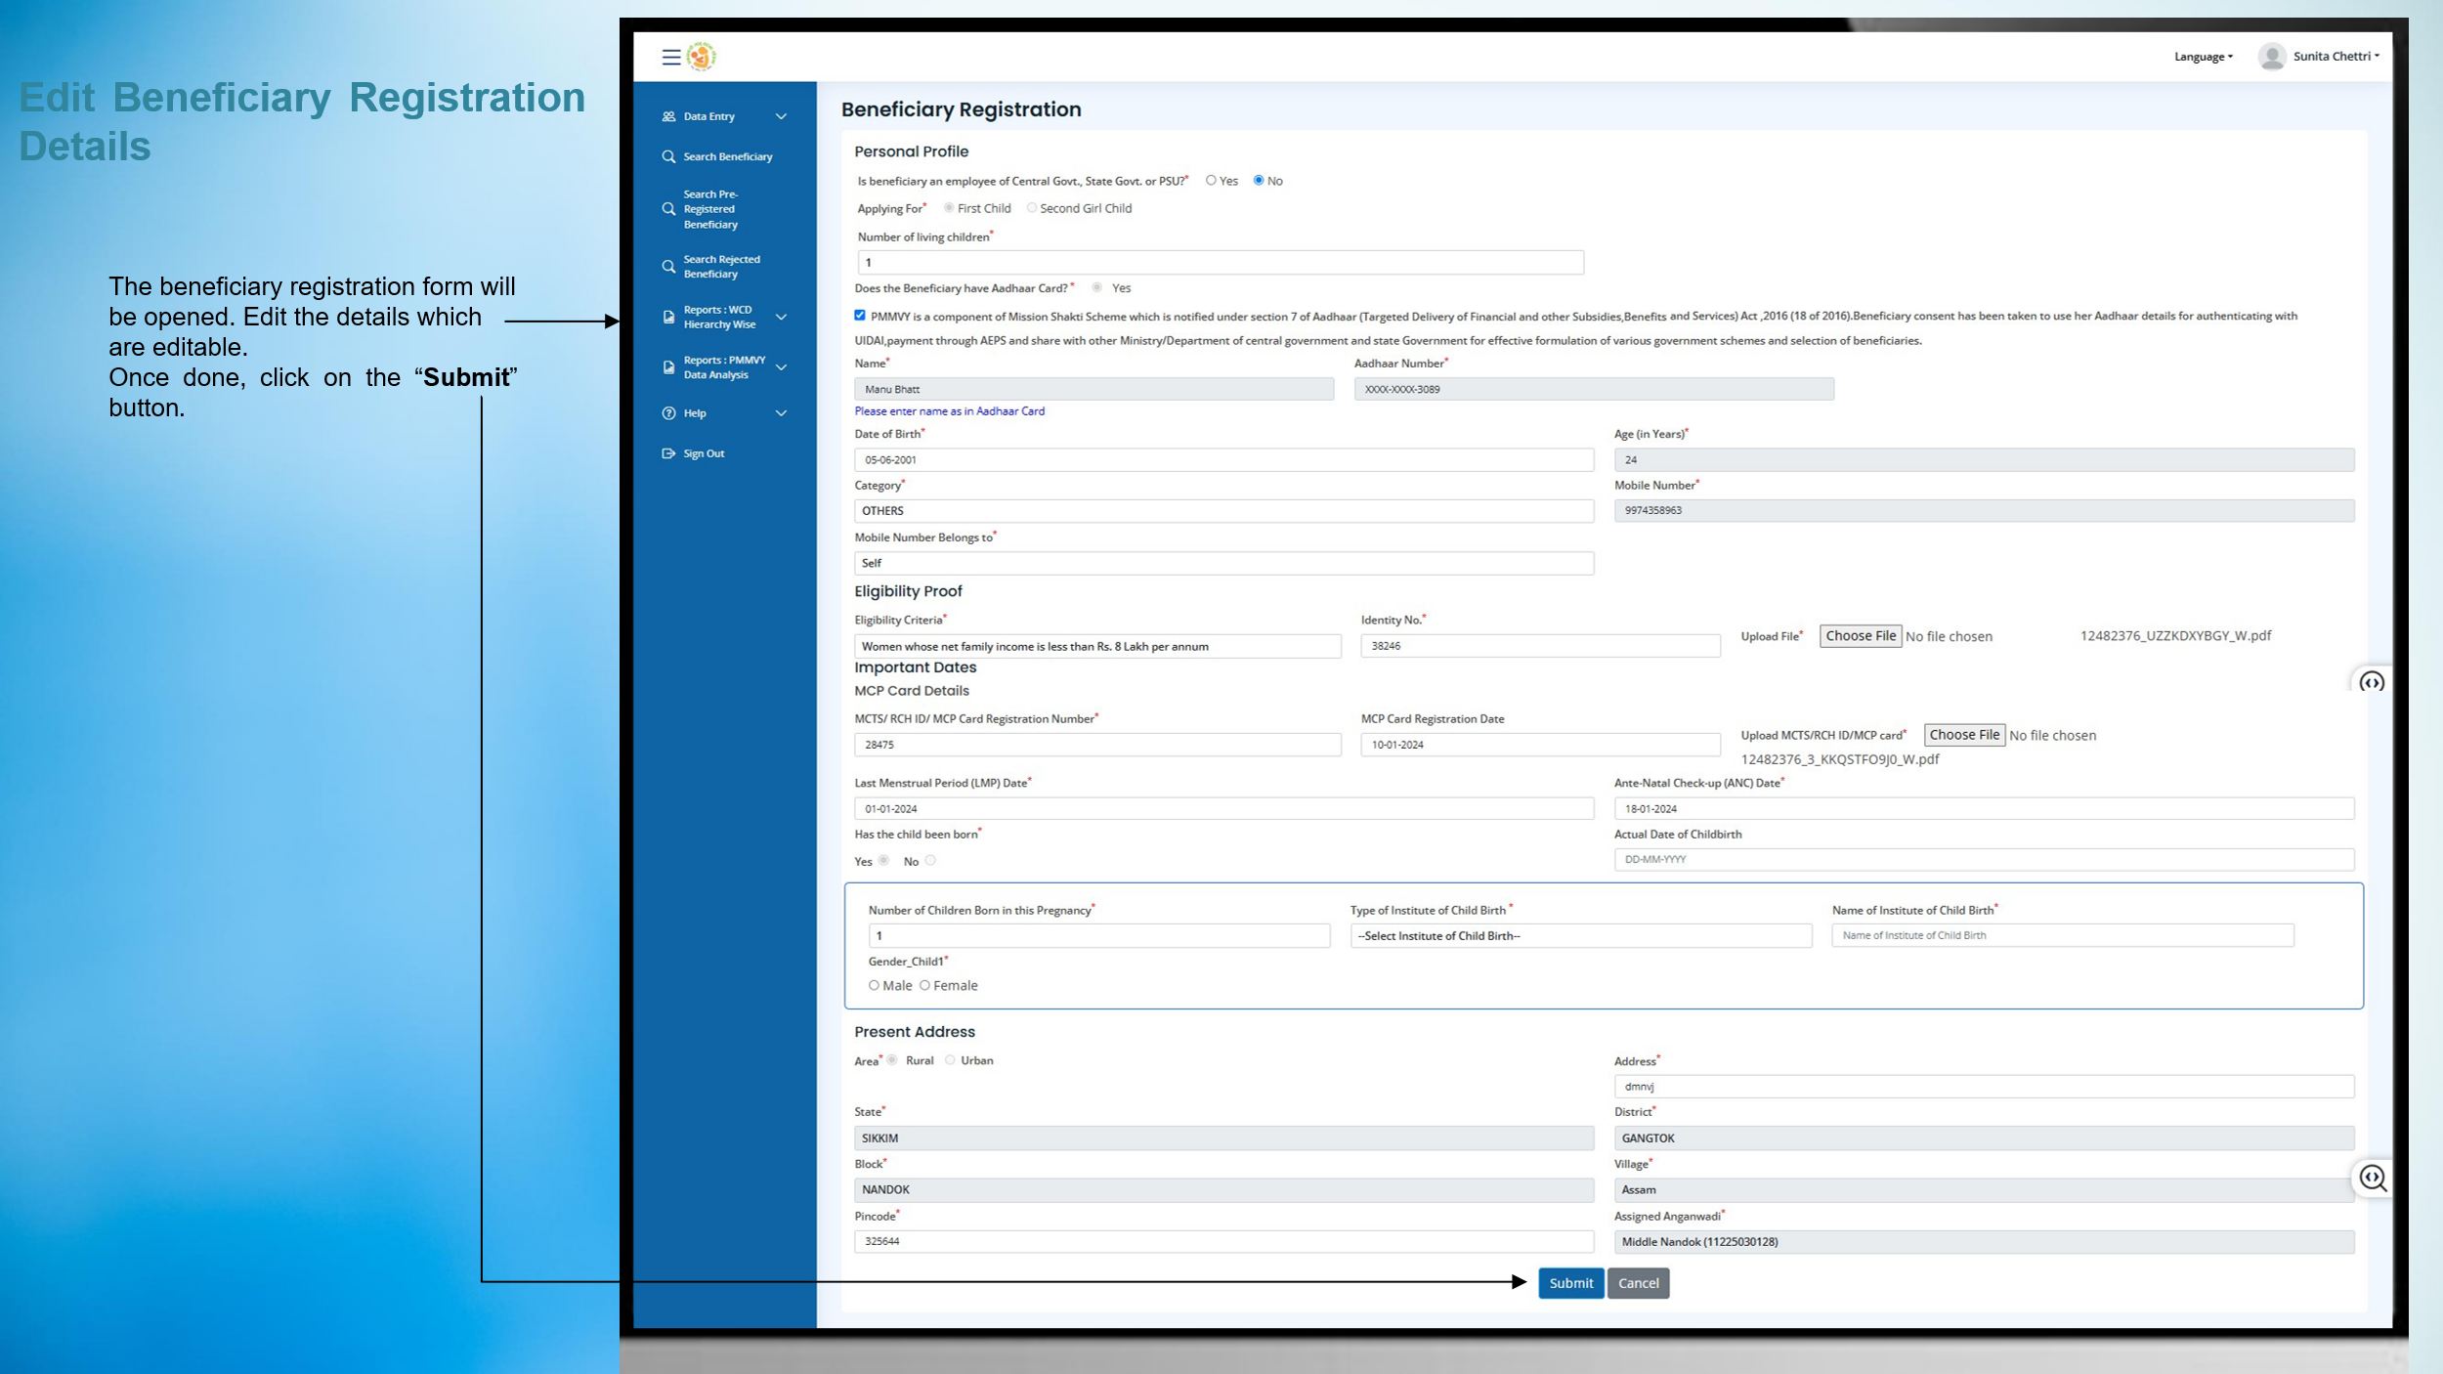

CHAPTER 7: Verify Childbirth & Immunization Details
Supervisors must verify childbirth and immunization details entered by the Field Functionary before the installment processing can proceed. The steps are as follows:
- Click on “Data Entry” tab.
- Select “Verify Childbirth and Immunization”.
- List of beneficiaries will be displayed.
- Click on “Verify” button.
- Immunization details form will open.
- Review details filled by Field Functionary (AWW/ASHA).
- Click:
  - “Submit” → To verify details.
  - “Not Verify” → If details are incorrect.

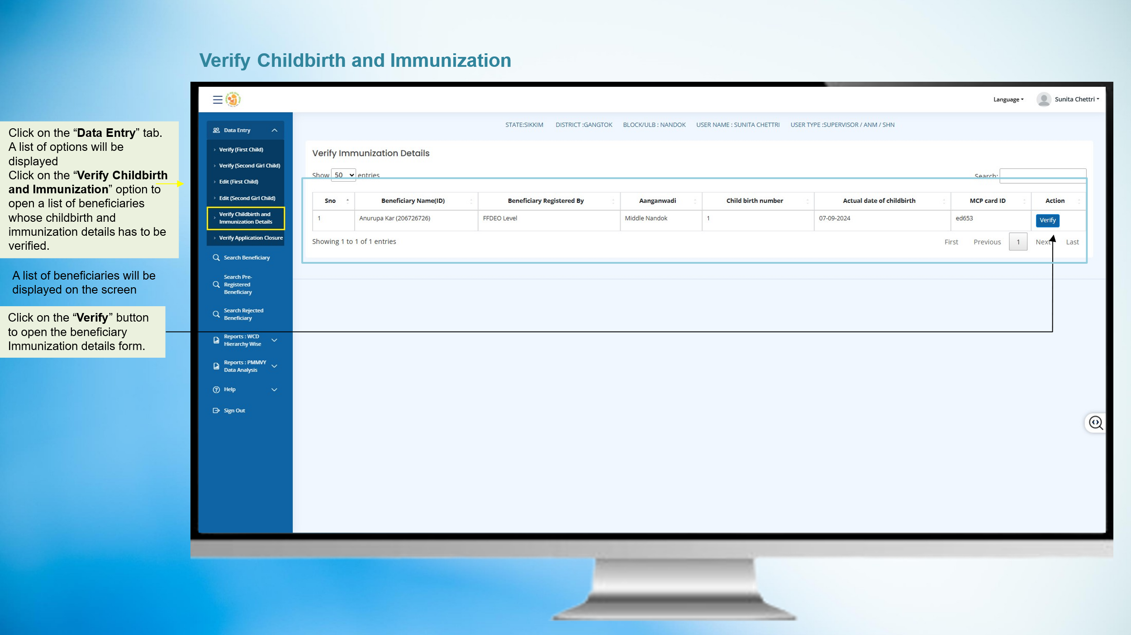

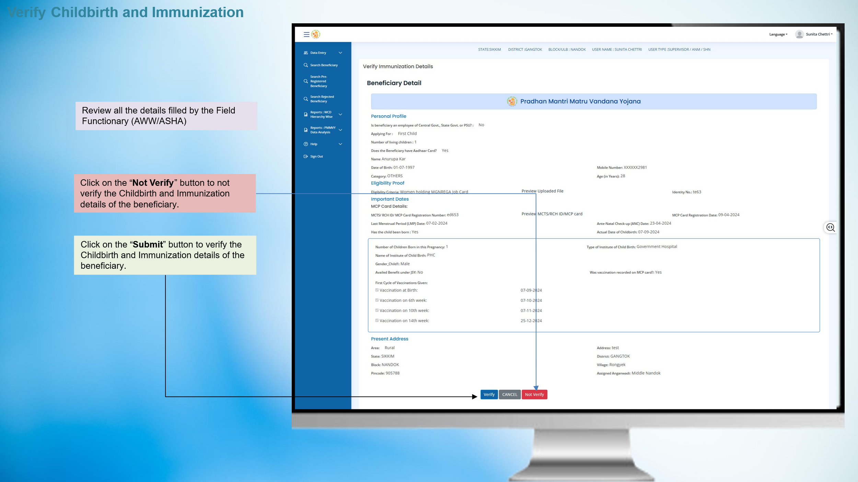


CHAPTER 8: Verify Application Closure (Case Closure)
In certain situations such as death, miscarriage, or other valid reasons, a case closure request may be initiated by the Field Functionary. The Supervisor must verify the closure request before it proceeds for final approval. The steps are as follows:
- Click on “Data Entry” tab.
- Select “Verify Application Closure”.
- List of closure requests will be displayed.
- Click on “Action” button.
- Closure form will open.
- Click:
  - Verify Case Closure
  - Not Verify Case Closure
- Note: In both cases, request goes to Sanctioning Officer (CDPO/MO/THO).
- Final closure happens only after Sanctioning Officer approval.
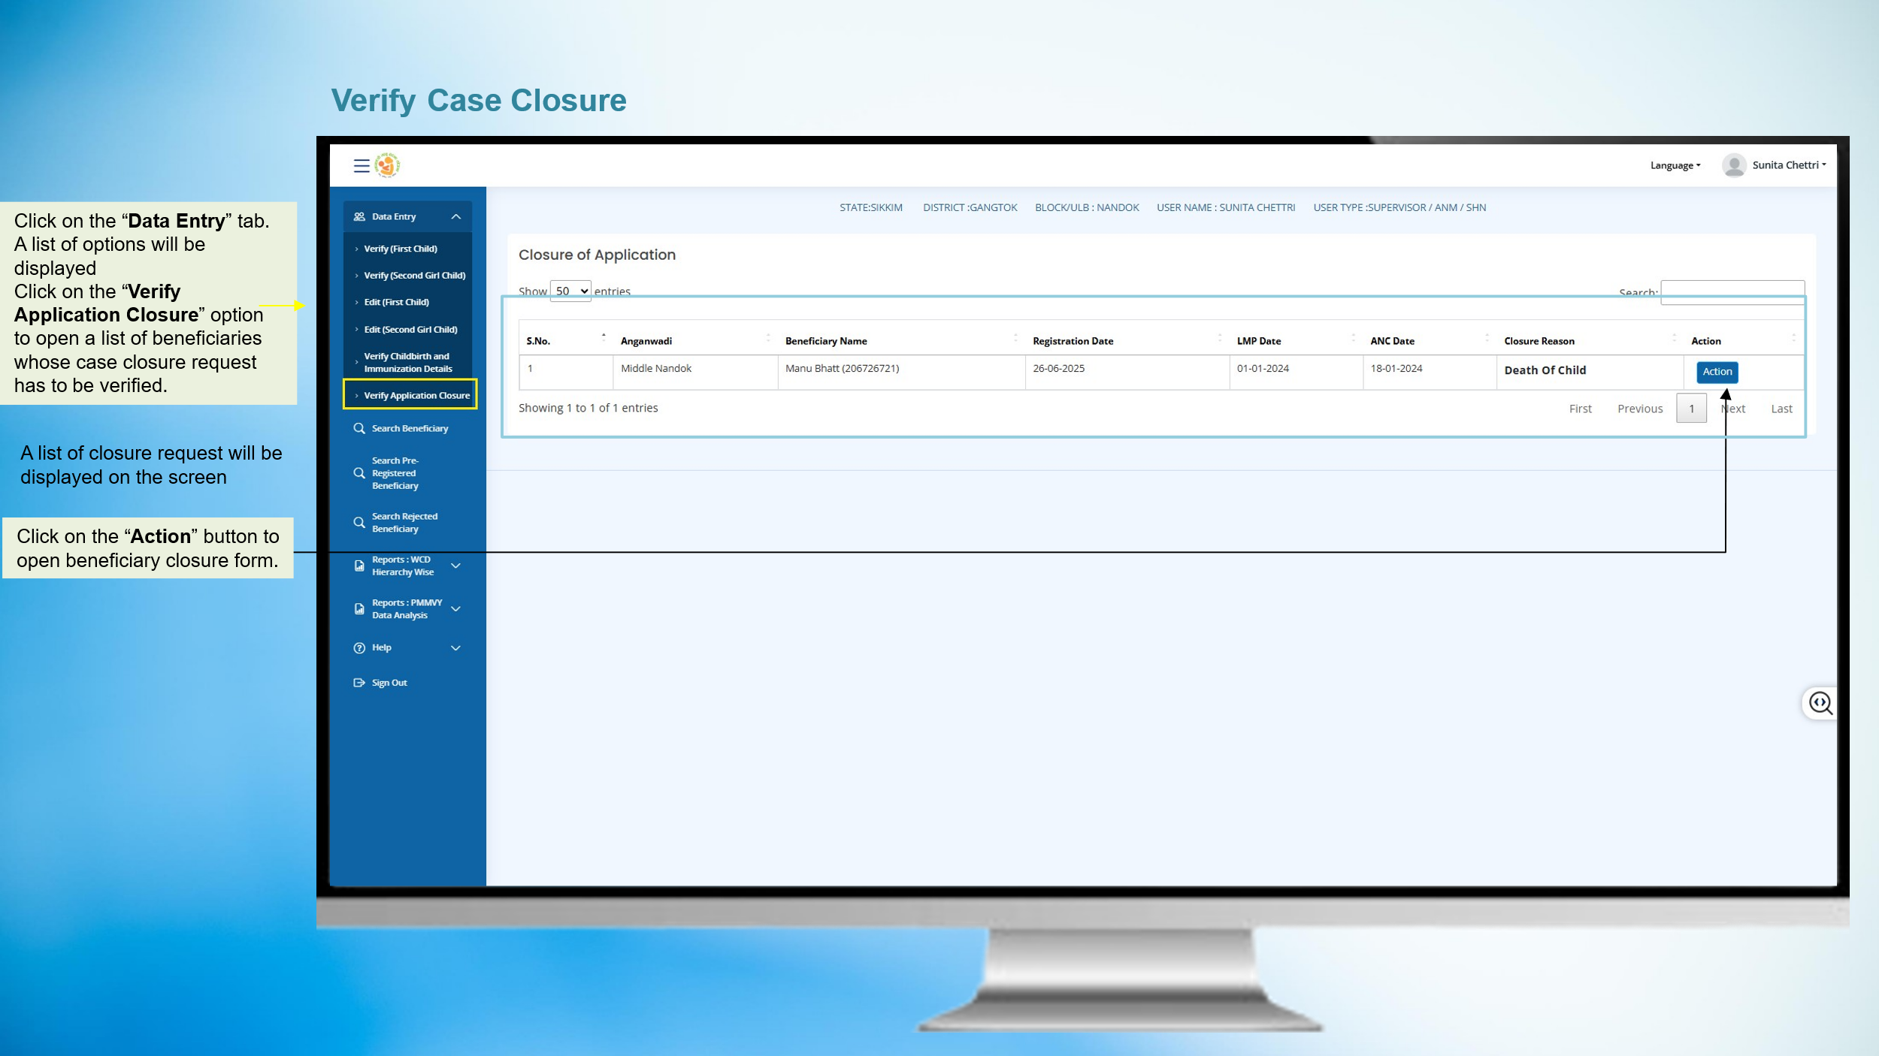



CHAPTER 9: Face Authentication of Field Functionaries (AWW/ASHA)
Supervisors can perform face authentication of Field Functionaries to enable Aadhaar-based verification within the system.
- Click on “Data Entry” tab.
- Select “Face Authentication of Field Functionaries (AWW/ASHA)”.
- Camera screen will open.
- Click the picture of the Field Functionary (AWW/ASHA).
- Click on Authenticate.
- System will process the face authentication.
- Once successful, a message will appear:
“Face is Successfully Authenticated.”

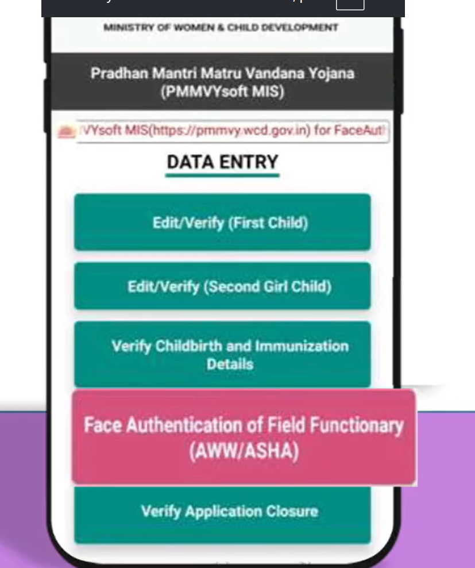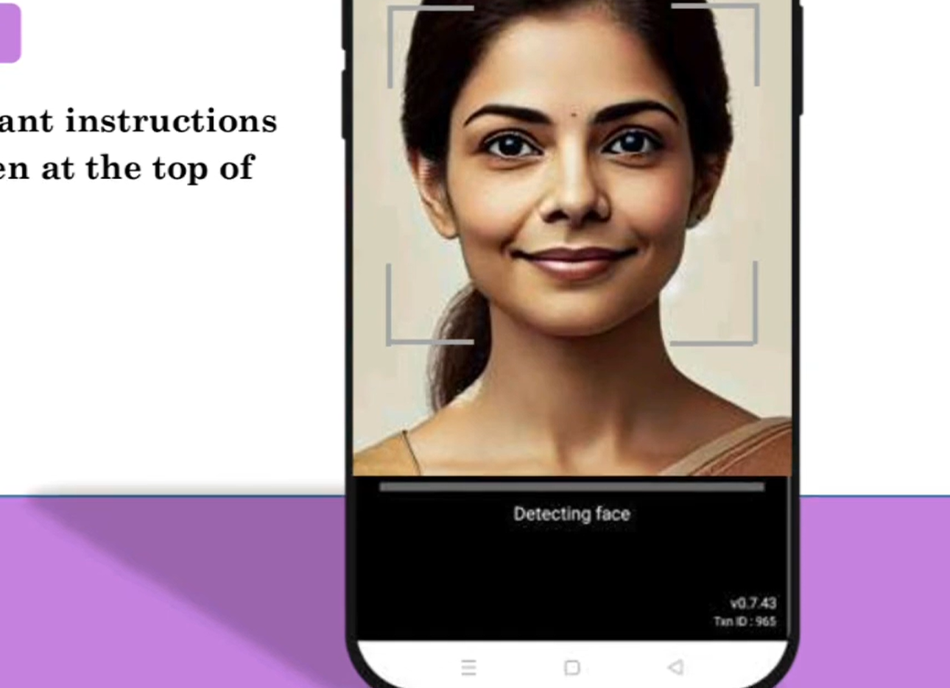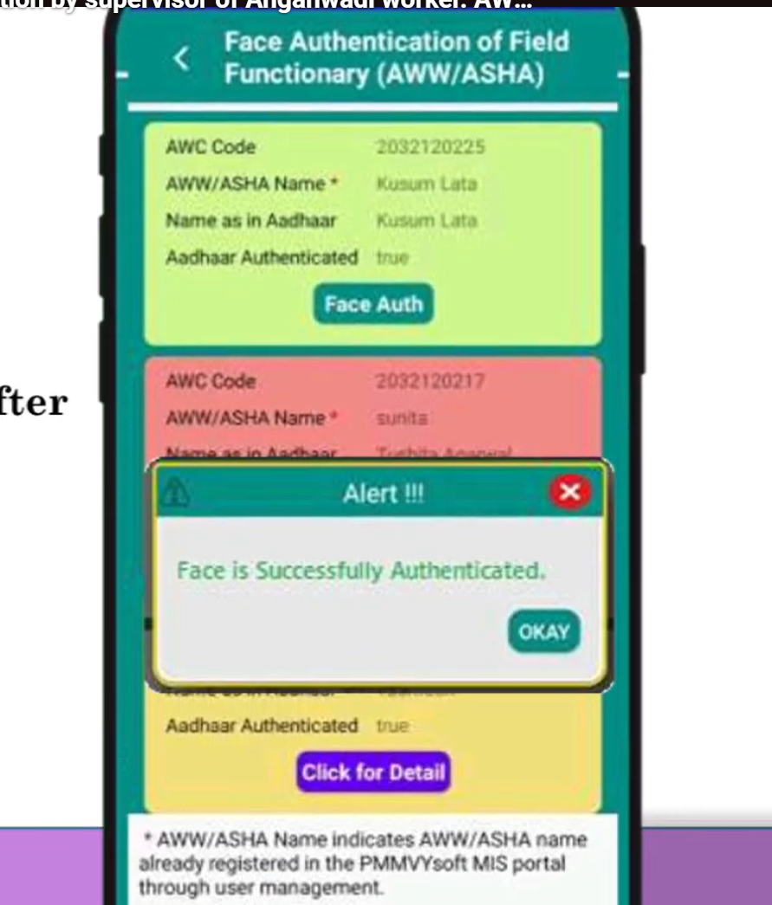

Update Residency Period of Field Functionary (AWW/ASHA) ​
Supervisors may update the residency period details of Field Functionaries when required.

Verify documents
- Cross-check Aadhaar, MCP card, and Anganwadi register.
Login to PMMVY portal
- Use Supervisor credentials.
Search beneficiary profile
- Enter Beneficiary ID/Aadhaar.
Click Edit / Modify option
- Open the incorrect field.
Update correct residency period details
- Correct the mistake (residency).
Upload supporting document
- If portal requires proof.
Save and Submit
- Forward for approval (if needed).
Confirm correction
- Check status after approval.
- Inform AWW.

CHAPTER 10: REPORTS
Search Beneficiary
Supervisors can search for beneficiaries in the system when verification or review of records is required.
Beneficiary can be searched by:
• Beneficiary Name
• Aadhaar Number
• Mobile Number

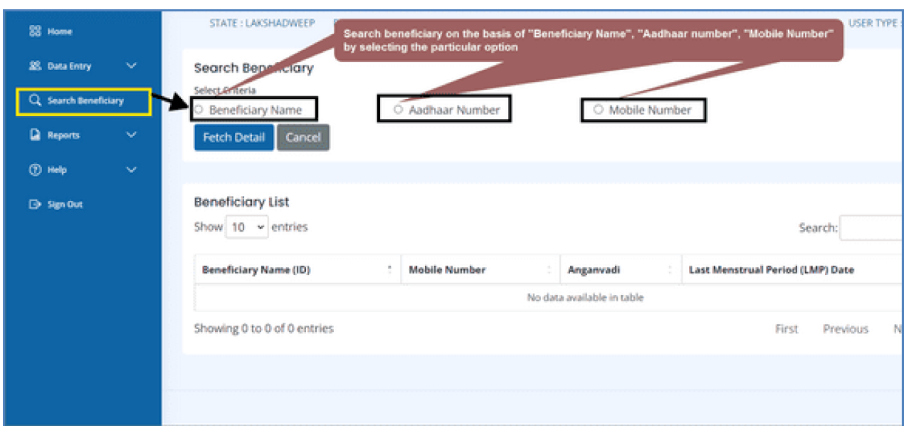
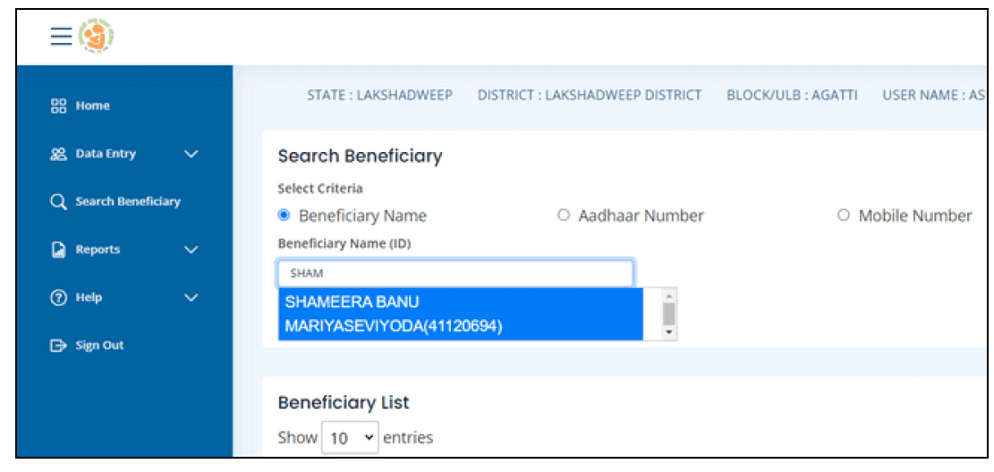
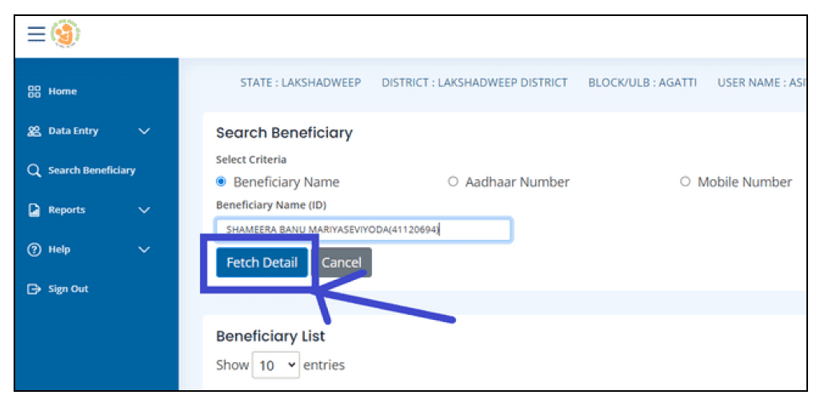

Reports

